**DAILY ONLINE ACTIVITIES SUMMARY**

|  |  |  |  |  |  |  |  |  |
| --- | --- | --- | --- | --- | --- | --- | --- | --- |
| **Date:** | **11-6-2020** | | | | | **Name:** | **Likhitha.M** | |
| **Sem & Sec** | **6th sem ‘A’** | | | | | **USN:** | **4al17cs046** | |
| **Online Test Summary** | | | | | | | | |
| **Subject** | | **Python Application Program – assignment 3** | | | | | | |
| **Max. Marks** | | **20** | | **Score** | | | **20** | |
| **Certification Course Summary** | | | | | | | | |
| **Course** | **Introduction to Ethical Hacking** | | | | | | | |
| **Certificate Provider** | | | **Great learning** | | **Duration** | | | **3 days** |
| **Coding Challenges** | | | | | | | | |
| **Problem Statement:**  1.Write a Java program to find the nodes which are at the maximum distance in a Binary Tree  2. Write a python function that converts a string to all uppercase, provided it contains at least 2 uppercase characters in the first 4 characters. Else print the string as it is 1)Input: Given string is : HeLlo Output string is: HELLO   1. Input: Given string is : Hello Output string is: Hello | | | | | | | | |
| **Status: completed** | | | | | | | | |
| **Uploaded the report in Github** | | | | | **yes** | | | |
| **If yes Repository name** | | | | | **https://github.com/likhithaMantaral/Daily-status** | | | |
| **Uploaded the report in slack** | | | | | **yes** | | | |

Online test Details:

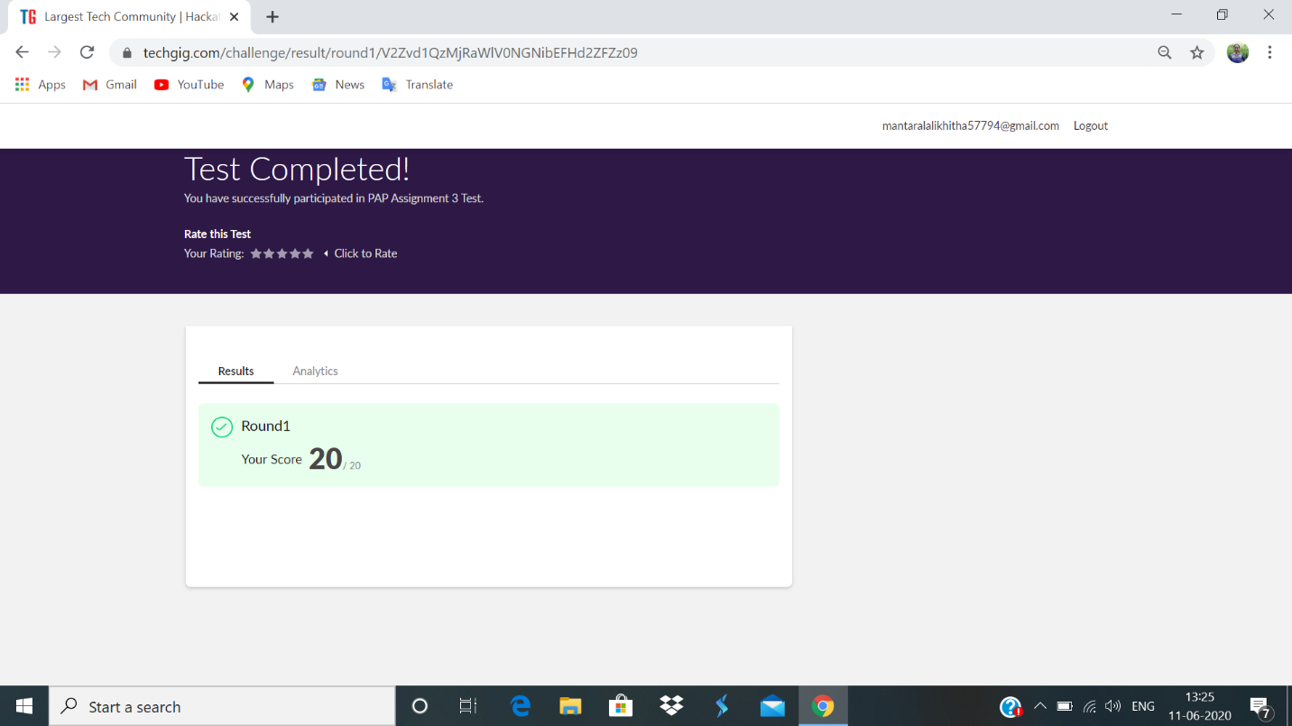

Certification Course Details:

**Successfully completed the course- Introduction to Ethical Hacking**

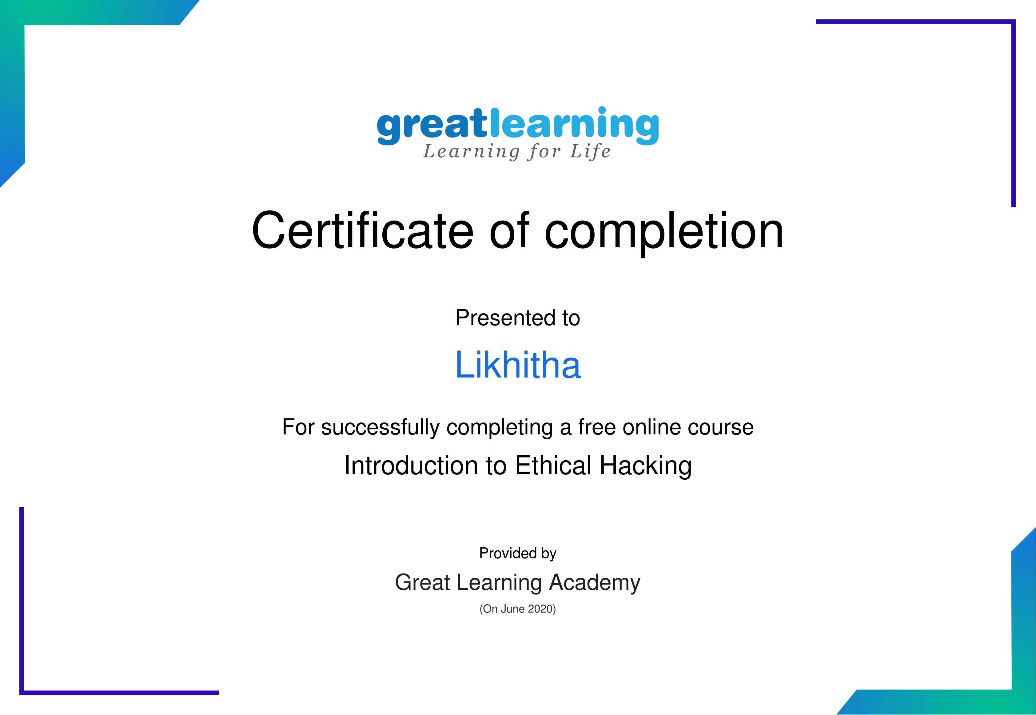

**Coding challenge:**

**1.**

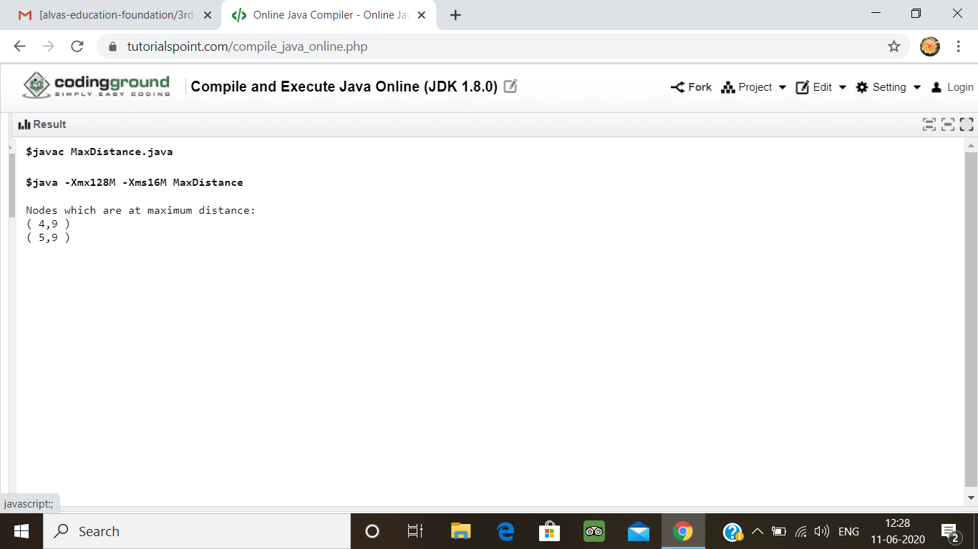

2.

